Instructions

There will be 3 parts to this project. You will interview one or more family members to learn about your family history, then put the information all together into a PowerPoint presentation.

Your project will consist of the following:

|  |  |  |
| --- | --- | --- |
| Part 1 – Interview family member(s) | Due Date: |  |
| Part 2 – Create a Family Tree | Due Date: |  |
| Part 3 – Create PowerPoint | Due Date: |  |

Below are some topics to include in your family history research, and some questions to help with the interview.

**Part 1 – Interview Family Member(s)**

Life

1. Ask one or two family member(s) what life was like for them.
2. Make a summary of their answers.  
   (and take notes about information you can use for the family tree as well).

Questions to help guide you and to give you some ideas:

* + - What is your birthday?
    - What year were you born?
    - Where were you born?
    - How many brothers and sisters do you have?
    - Who lived with you growing up?
    - Where did you live when you were my age?
    - What kind of building did you live in?
    - What chores did you have when you were my age?
    - What is the happiest memory from your childhood?
    - How did you get groceries?
    - What were the stores like?
    - When were stores open?
    - What was transportation like?   
      (bus, train, tram, trolley, subway, cars, etc.)
    - What did you do after school every day?   
      (for example: paper route, watch TV, etc.)
    - What did you do after you finished high school?  
      (family, work, travel, moved, etc.)
    - What did you do for fun when you weren’t in school?
    - What were your toys like?

School and Education

1. Pick one or two family members and ask them about what school was like for them.
2. Make a summary of your information (any pictures would also help, but are not necessary).

Questions to help guide you and to give you some ideas:

* Where did you go to school?
* What was school like?
* What kind of building was it?
* How big was the school?
* How many students were in your school?
* How big were the classes?
* How far was school?
* How did you get to school every day?
* How did you learn?
* What did you wear?
* How were you assessed (test, oral presentations, etc.)?

Places / Locations

1. Provide some information about places in your family history.
2. Use a map or pictures to show some information about your family.   
   🡪If your family has never lived anywhere other than in the same place, that’s OK! You can still include information and a map of that area.

Questions to help guide you and to give you some ideas:

* Where were some of your family members born?
* Is there a specific country or a specific city where people have lived?
* What are some important places in your family history?
* Why are they important? (i.e. vacation location, birth place/country, school/education, etc.)

Dates/Times

1. Please use a timeline to list some important times or dates in your family history.
2. Label the timeline or chart with dates and events.
   * Use any pictures or drawings to show some important times.
   * What are some important events in your family’s history?
   * Are there any important births, deaths or marriages?
   * Did anyone move or change countries?
   * What are some important memories?

**Part 2 – Create Family Tree**

1. AFTER you interview you family member(s), try to make a family tree for 3 generations.   
   (you, your parents, your grandparents)
2. Include names (you don’t have to include last names).
3. Show how people are related.
4. Try to have at least 6 people on the family tree.
5. If you can, include some pictures.
6. What is some simple information about each person? (likes, interesting facts, job, etc.)

**Tip:**

* You can use a simple, online free family tree maker from: <https://www.familyecho.com/>
* Only enter information you wish to share in your presentation
* When you are finished, make sure the family tree is visible on your monitor/computer screen.
* On your keyboard you can press “prt sc” on the top row usually, which captures a picture of your computer screen and the family tree. (If you use a phone/tablet, you can take a screen shot by holding down the volume button and power button, but methods vary depending on your device.)
* The screen capture automatically puts it in your computer/phone/tablet memory.
* In PowerPoint, paste it as “Device Independent Bitmap” which is just a picture from memory.
  + Click on the “Home” tab
  + Click on the down arrow, and select “Paste Special”
  + Click on “Device Independent Bitmap”
  + Press OK

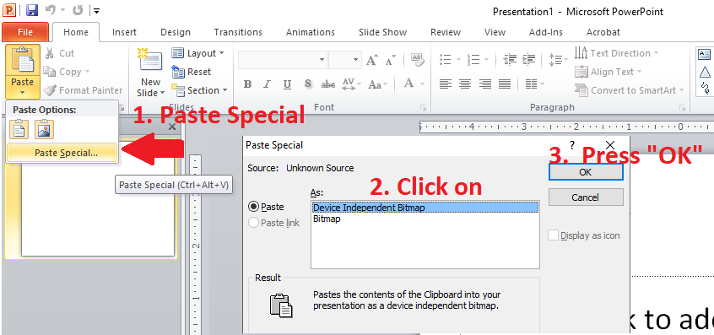 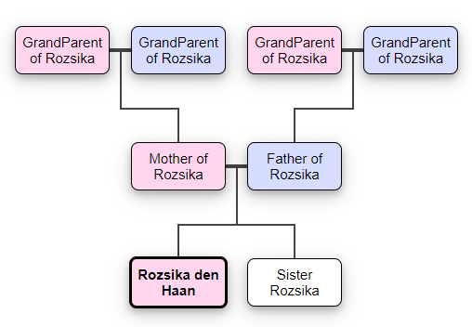

**Part 3 – PowerPoint Presentation**

**Instructions:** Using the information from your interview and family tree, you will create a presentation to put all your data together. Your PowerPoint should be a minimum of 10 slides.

|  |  |  |  |  |
| --- | --- | --- | --- | --- |
| **Criteria** | **Excellent**  **3 Points** | **Proficient/Good**  **2 Points** | **Satisfactory**  **1 Point** | **Needs Improvement**  **0 Points** |
| Introduction Page With:   * Title * Your Name * Grade * Date | All aspects are present. | Only 3 aspects are present. | Only 1-2 aspect are present. | No title page is present. |
| Family tree including:   * Names * How people are related * 6 people minimum * Simple info about each person | All aspects are present. | Only 3 aspects are present. | Only 1-2 aspect are present. | No family tree. |
| Minimum 3 slides on family member’s life | 3 or more slides are present. | Only 2 slides are present. | Only 1 slide is present. | No slides present about this topic. |
| Family member’s life is summarized in the 3 slides with information such as:   * Details * Family * Interests | Substantial amount of information provided in the slides. The information is detailed and specific. | Some information is present in the slides. Information is not very detailed. | Some information is present.  Information is too vague, or too simple. | Topic is not present, or very little information available. |
| 1 slide on Places / Locations, including pictures. | Key places are mentioned. Relevant picture(s) are used. | Either Key places are mentioned, or relevant picture is used, but not both. | No key places are mentioned, or picture is used, but perhaps not related. | No key places are mentioned.  No picture used. |
| Minimum 1 slide on school and education. | Substantial amount of information provided in the slides. The information is detailed and specific. | Some information is present in the slides. Information is not very detailed. | Some information is present.  Information is too vague, or too simple. | Topic is not present, or very little information available. |
| 1 slide for timeline with:   * Dates * Events Labelled * Pictures | All aspects are present. | Only 2 aspects are present. | Only 1 aspect is present. | No timeline. |
| Conclusion   * 3 things that you learned from this project. | At least 3 details are provided. | At least 2 details are provided. | Only 1 detail is provided. | No conclusion. |